Subject: Congratulations – Selected for Round 2 | Assignment Details
Congratulations!
You have successfully cleared the first round of the interview, and we are pleased to inform you that you have been shortlisted for the second round.
Based on your first-round assignment, the second round will focus on customization and enhancements to the current design that you created.

Round 2 – Design Customization Task
- Hero Section
  - Add a custom construction AI–centric animation in the background of the hero section.
  - The animation should align with the AI + construction theme and maintain a clean, professional look.

- Mobile Navigation Bar
  - Modify the mobile navigation bar functionality.
  - Create a custom mobile navbar design as referenced in the shared screenshot.
  - Improve the overall mobile user experience.
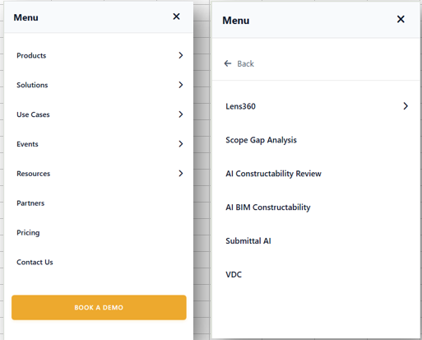

- “Built Around Construction Roles — Not Generic Software” Section (Mobile)
  - On mobile devices, apply a smooth scrolling effect to the following categories:
    - Owners & Developers
    - General Contractors
    - Trade Contractors
    - Architects & Designers
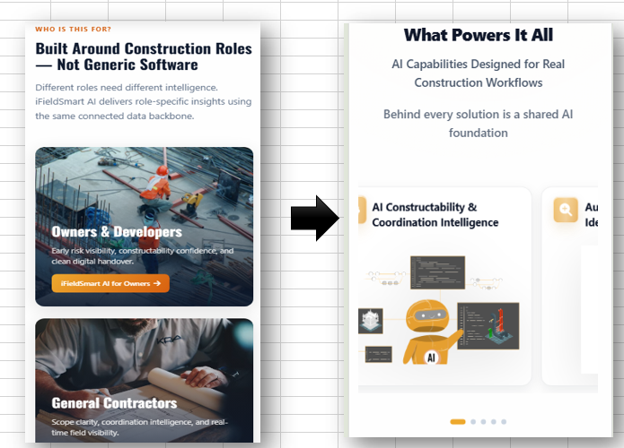
- Footer Section
  - Redesign the entire footer section according to the shared screenshot.
  - Ensure the structure, layout, and styling match the reference design.
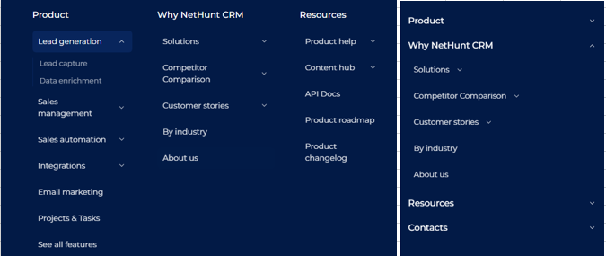

Timeline
The deadline to complete this assignment is 2 days.
Please ensure the task is submitted before the deadline.
If you successfully clear this round, you will be shortlisted for the final round, which will be a face-to-face interview and the last stage of the selection process.
We look forward to your updated submission.
Best of luck!

